Neural Network Fundamentals

Neural networks sound complex, but they're built from simple, repeating components. Just as skyscrapers are built from floors, rooms, and bricks, neural networks are built from layers, neurons, and mathematical operations. In this lesson, we'll break down exactly how these components work and fit together. You'll learn what individual neurons do, how they're organized into layers, and how these structures process information from input to output.
1. Neurons and Layers: The Architecture
Imagine you're building a decision-making committee. Each member (neuron) receives information, weighs it based on their expertise, and passes their opinion to the next level. That's essentially how a neural network operates.
A neuron is the fundamental computing unit in a neural network. Think of it as a tiny mathematical function that takes multiple inputs, processes them, and produces a single output. Here's what happens inside:
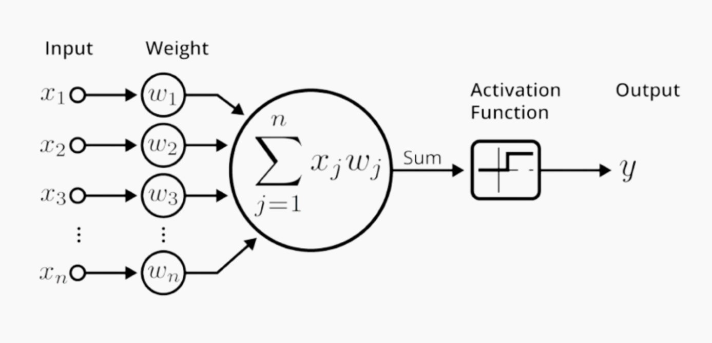
Figure - Anatomy of an Artificial Neuron
- Each input arrives with a weight—a number indicating how important that input is (like how much you trust different news sources)
- The neuron multiplies each input by its weight and sums everything up
- This sum passes through an activation function (we'll explore this next) that decides what signal to send forward
These neurons aren't scattered randomly, they're organized into layers:
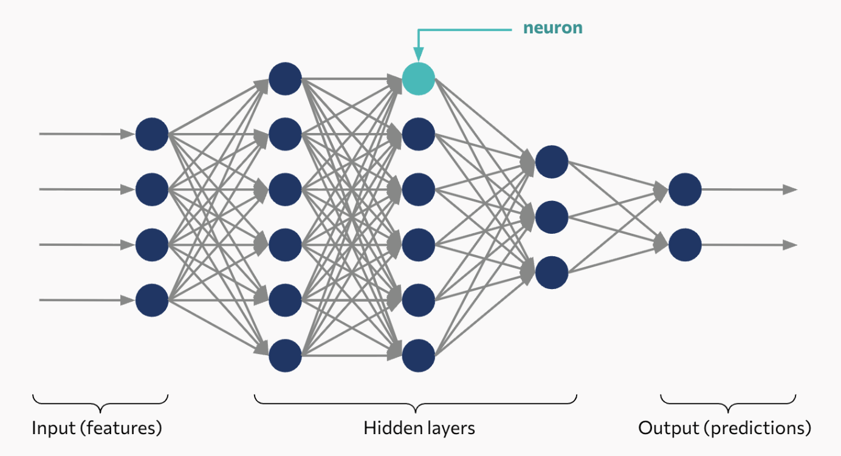
Figure - Neural Network Architecture
- Input layer: Where your raw data enters (like pixels in an image or words in a sentence)
- Hidden layers: Where the real magic happens—these intermediate layers extract increasingly complex patterns
- Output layer: Where predictions emerge (like "this is a cat" or "this email is spam")
Intuition: Think of layers like a factory assembly line. Raw materials enter, each station transforms them incrementally, and finished products emerge. The input layer receives raw data, hidden layers refine it into useful features, and the output layer delivers the final prediction.
2. Activation Functions: Adding Non-Linearity
Now here's a crucial question: why can't we just keep adding up weighted inputs forever? Because without something to add complexity, our network would be nothing more than a fancy linear equation, incapable of learning the intricate patterns in real-world data.
Enter activation functions: these are the components that introduce non-linearity. After a neuron sums its weighted inputs, the activation function decides what actually gets passed forward. Think of it as a gatekeeper applying a transformation rule.
The three most common activation functions each serve different purposes:
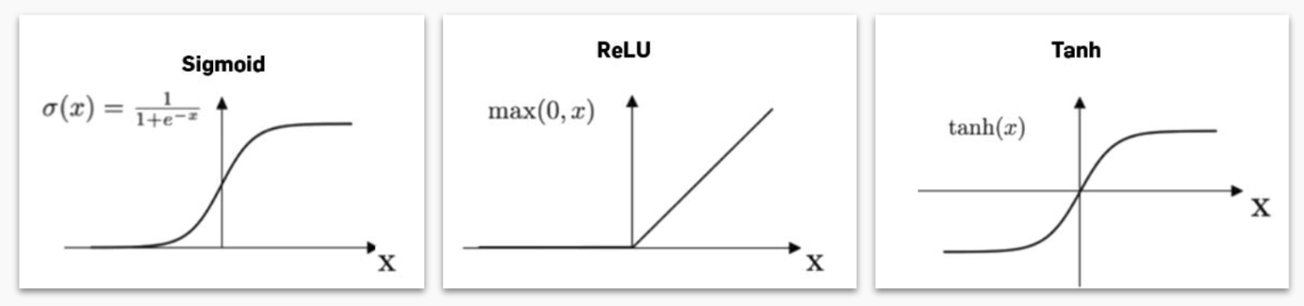
Figure - Common Activation Functions
Sigmoid ($σ(x)=1/(1+e^{-x})$)
- Squashes any input into a range between 0 and 1
- Useful for probability outputs
- Acts like a smooth on/off switch
ReLU (Rectified Linear Unit: $max(0,x)$)
- If input is positive, pass it through unchanged
- If input is negative, output zero
- Simple, fast, and surprisingly effective—the workhorse of modern deep learning
Tanh (hyperbolic tangent)
- Similar to sigmoid but ranges from -1 to 1
- Centers outputs around zero, often helping with learning
Example: In a weather prediction model, these functions serve different purposes. Sigmoid converts any input into a probability (0 to 1), useful for questions like "will it rain?" ReLU creates a clear threshold: it outputs zero below a certain point and increases linearly above it. Tanh provides a symmetric range from -1 to +1, effectively representing strength and direction of a signal.
3. Defining a Deep Learning Model
Let's build your first neural network. Here's how you define a model's architecture in Keras:
model = Sequential()
model.add(Dense(32, input_dim=364))
model.add(Activation("tanh"))
model.add(Dense(1))
model.add(Activation("sigmoid"))
Step-by-step explanations:
- Sequential() : Creates a neural network where layers are stacked one after another
- Dense(32, input_dim=364): Adds a layer with 32 neurons that receives 364 input features
- Activation("tanh"): Applies the tanh activation function to that layer's output
- Dense(1): Adds a final layer with 1 neuron for the prediction
- Activation("softmax"): Converts the output into a probability
This is the blueprint of your network—defining how many layers you have, how many neurons in each, and what activation functions to use. Once defined, the model is ready to learn from data (which we'll cover in the next lesson).
Key Takeaways
- Neural networks consist of interconnected neurons organized in layers (input, hidden, output), where each neuron computes a weighted sum of inputs and applies an activation function
- Activation functions (ReLU, sigmoid, tanh) introduce non-linearity, transforming neural networks from simple linear equations into powerful function approximators capable of modeling complex relationships
- The architecture—number of layers, neurons per layer, and activation functions—defines what patterns your network can potentially learn, but actual learning requires training (covered next)

